**Crowdfunding Data Analysis Report**

Q: Given the provided data, what are three conclusions that we can draw about crowdfunding campaigns?

A: Based on the analysis of the provided data, the following three conclusions can be drawn about crowdfunding campaigns:

Seasonal Success Rate: The data indicates that crowdfunding campaigns have the highest success rate during the summer months, particularly in June and July. This finding suggests that launching a crowdfunding campaign during these months may increase the likelihood of success.

Dominance of Theater Category: Among the various crowdfunding categories, Theater emerges as the category with the highest number of crowdfunding requests. Within the Theater category, plays have the highest number of crowdfunding requests. This observation implies that the theater industry has a strong presence in crowdfunding, with plays attracting significant interest and support from backers.

Average Donation by Category: Theater and Film & Video-based crowdfunding campaigns receive the highest average donations. This finding suggests that these categories tend to attract backers who are willing to contribute larger amounts. It indicates a favorable reception and support from the crowdfunding community for projects in the theater and film industry.

Q: What are some limitations of this dataset?

A: The limitations of the dataset include:

Absence of Customer Satisfaction Ratings: The dataset does not provide information on customer satisfaction ratings for successful crowdfunding campaigns. This limitation hinders a comprehensive assessment of the overall success and impact of these campaigns beyond their funding achievements.

Incomparable Currencies: The crowdfunding amounts in the dataset are represented in different currencies, making direct comparisons challenging. To accurately compare funding amounts across campaigns, currency conversion would be required.

Q: What are some other possible tables and/or graphs that we could create, and what additional value would they provide?

A: Additional tables and graphs that can be created for further analysis include:

Scatter Plot of Funding Amounts by Category: A scatter plot can be created to visualize the relationship between funding amounts and categories. This analysis can help identify the popularity and interest in specific crowdfunding topics, providing insights into potential success based on the level of interest in each category.

Stacked Bar Graph of Common Keywords in Successful Categories: By analyzing the most common keywords used in successful campaigns, a stacked bar graph can be created to highlight the keywords associated with success. This visual representation can assist in predicting specific interests that attract both success and income. It would require an AI-based application to identify the most common words automatically. An alternative approach using Excel would involve a labor-intensive process of separating the text into columns and using a pivot table to analyze keywords by category.

Q: Does the Mean or Median better describe the data?

A: The median is a more appropriate measure to describe the data in this case. The presence of outliers and high variability in the number of backers versus outcomes can skew the mean. Using the median provides a more robust measure of central tendency that is less affected by extreme values.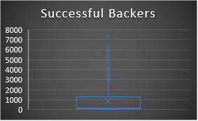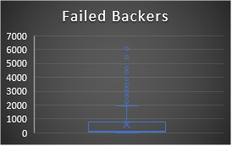

Q: Use your data to determine if there is more variability with successful or unsuccessful campaigns. Does this make sense? Why or why not?

A: There is generally more variability in successful campaigns compared to unsuccessful campaigns. This is primarily due to the higher variance in successful campaigns resulting from a larger dataset, higher numbers of backers, and potential outliers. Successful campaigns often exhibit higher levels of support, greater funding amounts, and efficient business practices. Conversely, unsuccessful campaigns tend to have fewer backers and a narrower range of outcomes, resulting in lower variability. However, the introduction of high-volume backed unsuccessful campaigns can increase variability in certain instances. Combining the data sets for canceled and unsuccessful campaigns may yield different results.